**9. ReactJS-HOL**

**App.js**

import React from 'react';

*// ListofPlayers Component*

const ListofPlayers = ({ players }) => {

  return (

    <div>

      {players.map((item) => (

        <div key={item.name}>

          <li>Mr. {item.name} {item.score}</li>

        </div>

      ))}

    </div>

  );

};

*// Scorebelow70 Component - Filters players with scores below 70*

const Scorebelow70 = ({ players }) => {

  const playersBelow70 = [];

  players.map((item) => {

    if (item.score <= 70) {

      playersBelow70.push(item);

    }

  });

  return (

    <div>

      {playersBelow70.map((item) => (

        <li key={item.name}>Mr. {item.name} {item.score}</li>

      ))}

    </div>

  );

};

*// OddPlayers Component*

const OddPlayers = ({ first, third, fifth }) => {

  return (

<div>

      <li>First: {first}</li>

      <li>Third: {third}</li>

      <li>Fifth: {fifth}</li>

    </div>

  );

};

*// EvenPlayers Component*

const EvenPlayers = ({ second, fourth, sixth }) => {

  return (

    <div>

      <li>Second: {second}</li>

      <li>Fourth: {fourth}</li>

      <li>Sixth: {sixth}</li>

    </div>

  );

};

*// ListofIndianPlayers Component*

const ListofIndianPlayers = ({ IndianPlayers }) => {

  return (

    <div>

      {IndianPlayers.map((player, index) => (

        <li key={index}>Mr. {player}</li>

      ))}

    </div>

  );

};

const App = () => {

  // Flag variable - Change this to true or false to see different components

  var flag = false;

  const players = [

    { name: 'Jack', score: 50 },

    { name: 'Michael', score: 70 },

    { name: 'John', score: 40 },

    { name: 'Ann', score: 61 },

{ name: 'Elizabeth', score: 61 },

    { name: 'Sachin', score: 95 },

    { name: 'Dhoni', score: 100 },

    { name: 'Virat', score: 84 },

    { name: 'Jadeja', score: 64 },

    { name: 'Raina', score: 75 },

    { name: 'Rohit', score: 80 }

  ];

  if (flag === true) {

    return (

      <div style={{ padding: '20px', fontFamily: 'Arial, sans-serif' }}>

        <h1>List of Players</h1>

        <ul>

          <ListofPlayers players={players} />

        </ul>

        <hr style={{ margin: '20px 0' }} />

        <h1>List of Players having Scores Less than 70</h1>

        <ul>

          <Scorebelow70 players={players} />

        </ul>

      </div>

    );

  } else {

    const IndianTeam = ['Sachin1', 'Dhoni2', 'Virat3', 'Rohit4', 'Yuvraj5', 'Raina6'];

    const [first, second, third, fourth, fifth, sixth] = IndianTeam;

    const T20Players = ['First Player', 'Second Player', 'Third Player'];

    const RanjiTrophyPlayers = ['Fourth Player', 'Fifth Player', 'Sixth Player'];

    const IndianPlayers = [...T20Players, ...RanjiTrophyPlayers];

    return (

      <div style={{ padding: '20px', fontFamily: 'Arial, sans-serif' }}>

        <div>

          <h1>Indian Team</h1>

          <h1>Odd Players</h1>

          <ul>

<OddPlayers first={first} third={third} fifth={fifth} />

          </ul>

          <hr style={{ margin: '20px 0' }} />

          <h1>Even Players</h1>

          <ul>

            <EvenPlayers second={second} fourth={fourth} sixth={sixth} />

          </ul>

          <hr style={{ margin: '20px 0' }} />

          <div>

            <h1>List of Indian Players Merged:</h1>

            <ul>

              <ListofIndianPlayers IndianPlayers={IndianPlayers} />

            </ul>

          </div>

        </div>

      </div>

    );

  }

};

export default App;

**Output:**

When flag = True

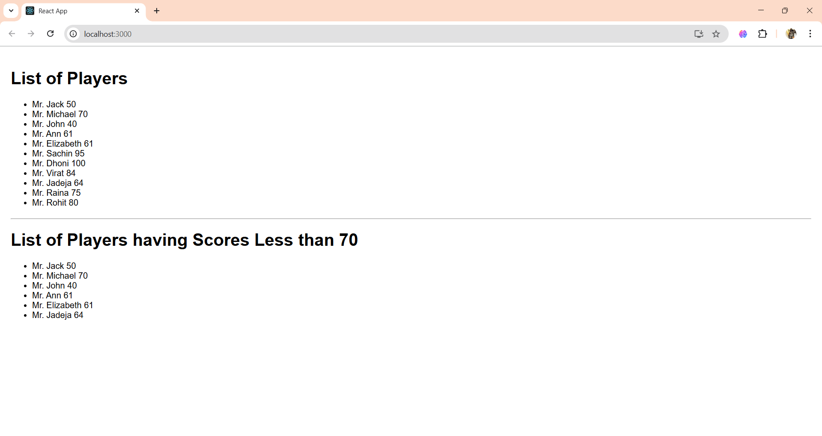

When flag=false

